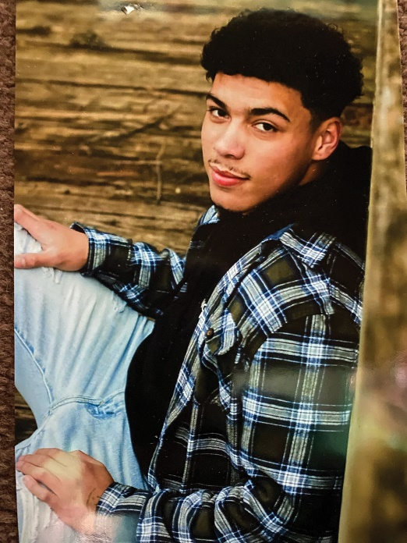
From Humble Beginnings
A long journey through foster care, a promising future ahead.

By all measures, Dominik, now 17, did not have an easy start in life. Shortly after birth, he was removed from his biological mother, who was incarcerated, and placed with his adoptive mom, Claudia. The two of them were strongly bonded and Dominick had a happy, stable childhood until 2015, when tragedy struck. Dom, only 9 years old, learned that Claudia was diagnosed with cancer. Only a short time later, she passed, and Dom found himself without parents for the second time in his short life.

After Claudia’s death, Dom was placed into a guardianship with a relative, but recalls that this was not the happily ever after he was hoping for. For two years, Dominick suffered physical and emotional abuse before their guardianship was terminated. At 12, Dom became a ward of the state, and began to bounce around between residential treatment facilities and psychiatric units before finally landing in a pre-adoptive placement with his best friend’s mom. After living there nearly a year, Dominick was relieved to finally be able to glimpse the light at the end of the tunnel. With the adoption papers in the judge’s hands, just days away from finalization, Dom got into a fight with his foster brother, and was kicked out of the house.

So Dom was forced to start over, yet again, in a new foster home. Due to the trauma he had experienced early on in life, he struggled with authority and often had difficulty regulating his emotions. After staying in this foster home for 8 months, Dominick was moved yet again. This is when he met Nikki Kaufman, his new CFS caseworker, and Sarah and Andy Melius, his new foster parents.
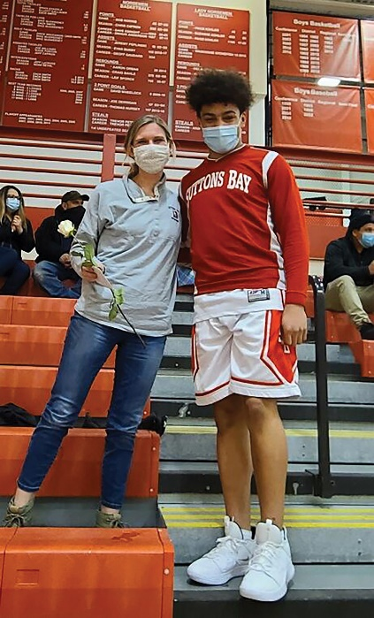
At the Meliuses, Dom fit in instantly. It wasn’t always easy, but his new family, especially their four young kids, absolutely adored him. After six months, however, things started to get rocky, and Dom ran away from home. This happened twice before he ended up in non-secure detention. After one week, Dom went AWOL and, when found, was sent to
secure detention for two months. During this time, the Meliuses continued to stay in contact with him. The kids would write letters, the family visited when they could,
and they participated in family counseling. After his two months were up, Dom returned home to the Meliuses, but again, he struggled. Two months later, he stole the
family car and ran away yet again. He was then placed in secure detention for the second time and stayed for nearly five months while the state tried to find a long-term foster placement that would be able to meet his needs. Still, the Meliuses stuck by him. Sarah and Andy’s daughter, June (age six at the time), would write Dom “notes” and mail them to him while he was in detention.

Nikki recalls June saying that even though Dom didn’t live in their house anymore, he was still a part of their family because he was in their hearts.

Typically when a child goes into detention, DHHS takes over case management. But in this instance, Nikki and the rest of the CFS team worked closely with DHHS so that she was able to remain as his caseworker. “The last thing he needed was another abandonment,” said Nikki. As much as the Meliuses were there for him, and as much as they hoped that Dom would get the treatment he needed to be able to live at home safely, there were no guarantees. “It was important to everyone that I be allowed to continue to advocate for him and keep him on my caseload,” Nikki said.

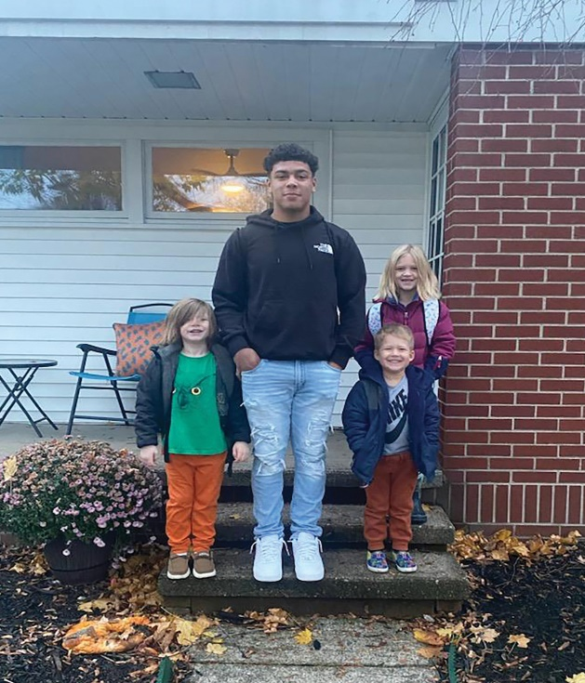
CFS supported Dom in other ways, too. “One thing people don’t know,” Nikki shared, “is that when a child is in detention, their Medicaid actually gets shut off.” In order for Dom to continue to receive counseling, both individually and with the Meliuses, CFS had to pay out of pocket. We were able to do this, in part, thanks to a grant from the Manistee County Community Foundation. “Being in jail, even kid jail, was not good for Dom,” Nikki recalls. “We know that when it comes to kids who make poor decisions and engage in criminal behavior, the root of that choice is their trauma. They have a lack of impulse control, an inability to make wise decisions. Dom was wired differently— he needed mental health treatment, not punishment.”

Finally, on April 27, 2022, Dom was accepted into Pioneer Mental Health facility. Seven months later, he had made enough progress that he was cleared to re-enter the community and was gladly welcomed home by the entire Melius family.

When Nikki first met Dom, she says, he was failing all his classes. He had no interest in college or a future whatsoever. He had no ability to look toward any long-term goals or consider the consequences of his actions. Today, Dominick is a high school graduate, his adoption into the Melius family will be finalized shortly, and he is headed to Ferris State University in the fall.

By all accounts, the Meliuses are a “regular” family. The only difference between them and any other family, said Nikki, is that they never gave up. When everyone else threw in the towel, the Meliuses kept going. “People might be scared,” Nikki says, “to take on something like this, because it is hard. It takes true love and dedication to change the lives of kids like Dom. Kids who have experienced more trauma than any of us can comprehend. But they didn’t ask for that. You have to be patient and kind. It’s our responsibility to care for the kids in our community, to care about the type of people who they’re going to be as adults, and to make them a part of our lives now.”

“I love Dom’s smile,” Nikki shared. “I love his ability to smile through the bad. He’s done enough work that he can let people in now. He’s finally in a place where he feels like he’s truly part of the family.”
