A Lifetime of Fostering Love

Amy Young is no stranger to foster care. When she was growing up, her parents were licensed foster parents and her family took in countless children in need of a home. Over the years, Amy’s parents have adopted twelve children out of foster care and raised 3 of their own biological kids, including Amy. The experience of living in a home with foster children made a lasting impact on her. “We had a lot of kids coming in and out of our house,” Amy recalls, “and they kind of stole my heart.”
One day, years later, Amy and her husband Tom were visiting Amy’s parents’ house. “They had been taking in respite kids,” Amy recalls, “and this little girl they were caring for came up and asked me, ‘Would you be my mommy?’ She was only five, and she was just looking for a mom.” That night, Amy couldn’t think about anything else. “At the time, I was in the process of opening a salon, but I couldn’t even sleep because of this little girl; because of all the other kids like her who were just looking for their parents.” Amy spoke to Tom about it and was thrilled to learn that he had been feeling the exact same way. “My husband was completely on board,” she says.
So Tom and Amy began the process of getting licensed for foster care with Child and Family Services. They fostered and ultimately adopted five children in addition to having five of their own biological children. This was eighteen years ago, and today, most of Tom and Amy’s kids are grown up and out of the house. “So we talked about it,” Amy says, ”and since most of our kids were moving into adulthood, we suddenly had all this extra space again. We decided that it just made sense to reopen our foster care license.”
But just before their license was about to be approved, the family experienced a major trauma–Tom suffered a stroke. “We had to rush him to Traverse City from Manistee, and the weather was bad,” Amy recalls. “It was a nightmare. The doctors said there was a very small chance that he would make it because too much time had elapsed since the stroke. But before he went into surgery, Tom looked at me and said, “Don’t worry, we’re going to be ok. We’ve got more kids to help.’”
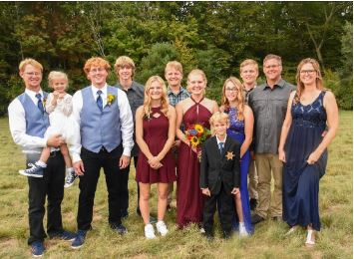
Incredibly, Tom was right. “Everyone at the hospital said it was an absolute miracle,” Amy says, “but he came out of surgery and everything went great.” After the stroke, Tom continued to show remarkable improvement, and six months ago, the Young’s foster care license was reopened. Today, they are fostering a sibling group of four young children, in addition to raising two of their own biological kids. Amy says things at home are great, if not a little chaotic from time to time.
“Sometimes I put pressure on myself to make everything go perfectly,” Amy says, “but that’s not really what matters. I wake up every day and I pray that God will help me to love them like Jesus does. We’re not perfect, but I don’t know that anybody is. We just do our best. That’s what it means to be a foster parent.” 