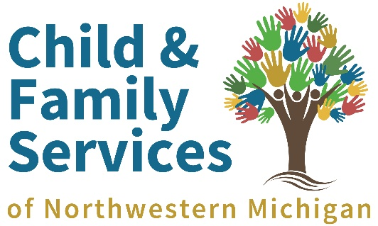
*Please, new items unless gently used is indicated.
Immediate Needs:
Diapers: Sizes 4-6, Pull-ups 2t-3t & 4t-5t
Newborn and preemie clothing
Wipes
Diaper cream
Pacifiers and bottles
Cups with lids for toddlers/young children
Emergency Supplies for Teens
Grocery store gift cards ($20 increments)
Fast food gift cards ($10 increments)
Granola bars and protein bars
Oatmeal packs Snack packs (crackers, nuts, healthy mix)
Hearty canned soups
Microwave meals (Uncle Ben’s, Barilla, No Ramen noodles please)
Personal hygiene products (full size)
Bata Passes
Gas cards ($20-$25 increments)
Ongoing Needs
Games, toys, crafts ie.-card games, interactive games for young kids, heavy duty toys/trucks/cars (Please no Jenga, ride on toys or large building blocks as we have plenty of these)
Books (learn to read and board books in particular)
Car seats (infant, convertible, booster)
CO2 detectors
Smoke alarms
Safety-proofing supplies (outlet covers, childproof locks for cabinets, toilets, lock boxes,
door alarms, padlocks)
Grocery store gift cards (Walmart, Meijer, Target: $20 increments)
Phone Cards (minutes/data) for visits/check- ins Gas cards ($10, $20, $25 increments)
BATA Passes
Fine line coloring books for teens/adults
Cash donations for Angel Fund: This direct client needs fund allows us to buy items for children and
families as needed for emergency needs, birthday gifts, transportation, a work uniform, music lessons,
sports equipment, etc.

YouthWork Wishlist
• up to $25
- We ALWAYS appreciate gift cards for fast food (BK, McDonalds, Jimmy Johns, Subway, etc.) or for local grocery stores for when our youth forget a lunch or deserve a special treat (we also appreciate longer-lasting snacks such as granola bars, protein bars, chips, snack packs, nuts, etc. for snacks for our kids throughout the day)
- Travel-sized hand sanitizer, toiletries, and other hygiene items for youth (both men and women - deodorant, shampoo, conditioner, body wash, tampons, feminine pads, etc.)
- Gas Cards ($10, $20, $25 denominations) for transportation needs
- Bug spray, sunscreen, bug spray, sunscreen, bug spray, sunscreen, bug spray, sunscreen, bug spray, sunscreen, etc (we use ALOT of this)
- First aid kits or gift cards to stock our first aid kits to keep kids and staff safe in the field
- cleaning supplies for around the office (teenagers are messy), and for cleaning vehicles. Wet wipes are amazing. We use a lot of windex and disinfectant in vehicles and around the office.
- Plants and nice decor/rugs/furniture that can be used at our office and in dorm rooms
• $26 to $100
- Nice quality coolers (lunch size or large), water bottles, backpacks, etc. for our youth to store lunch, etc on HOT summer workdays in the sun.
- Gift cards to Amazon, Action Supply, or home improvement/tool/equipment stores to purchase tools, supplies, and Personal Protective Equipment (PPE) for our crews to keep them safe while they're in the field completing conservation projects
- Winter Jackets, Winter Gloves, sweatshirts, etc. to keep our members warm as they complete projects during the winter months, as many do not have these and/or cannot afford quality/proper fitting warm weather gear (they deserve nice things, only GENTLY worn used items please).
- Donations of any amount to our "Angel Fund", a direct client needs fund which allows us to buy items for emergency needs or things like winter coats, transportation/bus passes, help a youth get a driver's license, a work uniform or tools, music lessons, sports equipment, specialized training, etc. (donate at www.cfsnwmi.org/youthwork)
• $101 to $500
- Gift cards of any amount to places such as Ace Hardware, Lowes, Menards, Home Depot, Blains, Tractor Supply, or similar stores to purchase tools, equipment, or supplies necessary to complete conservation projects in the field
- Donations of any amount to our "Angel Fund", a direct client needs fund which allows us to buy items for emergency needs or things like winter coats, transportation/bus passes, help a youth get a driver's license, a work uniform or tools, music lessons, sports equipment, specialized training, etc. (donate at www.cfsnwmi.org/youthwork)

Thank you!

